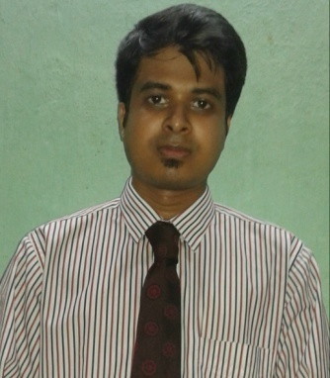

SUSMIT DAS
48/61, SWISS PARK,

TOLLYGUNJE Email: babansmith@gmail.com
KOLKATA-700033 Contact no : +91-9038087005

CAREER OBJECTIVE

Experienced and skilled marketing executive with great communication, organizational and management skills seeking for the challenging position in a reputable company.
EDUCATION QUALIFICATION

Passed Madhyamik from South Point High School under West Bengal Board of Secondary Education in 2002.

Passed Higher Secondary Examination under West Bengal Council of Higher Secondary Education in 2004.

Completed graduation in B.Com from South City College under Calcutta University in 2007.
PROFESSIONAL : Completed MBA (retail specialization) from Sikkim Manipal QUALIFICATION University in 2009.

PREVIOUS EMPLOYMENT
Worked as a Sr Business Development Executive for
Hyperlocal Tech Pvt Ltd (bytplus.com), from March,14 to Aug, 16.
JOB
RESPONSIBILITIES: Affiliate marketing in tying up with restaurants, spas & gyms.
Operational activities such as uploading of deals, writing up content of
service & offer details.
B2B tie up with various service related merchants on behalf of banking
Institutions.
EMPLOYMENT HISTORY

i) Started professional career working as a Business Development
Executive at Frankfinn Instituteof Air Hostess Training for over one
year, (Feb’10 to July’11)
JOB
RESPONSIBILITIES: Developing new markets for business activities.
Conducting seminars in various schools and colleges.
Supervising telecalling department.
Daily maintenance of MIS reports.

ii) Worked at Snapdeal.com Kolkata as Assistant Manager-Operations
since Aug, 2011 to Feb, 2013.
JOB
RESPONSIBILITIES: Completing Audits of all ongoing deals & the ones supposed to go
live in the future.
Training respective merchants & staffs about Snapdeal processes.
Negotiating about the terms & conditions of the deal.
To maintain good quality services from merchant’s end.
Preparation of Daily, weekly & monthly reports.
Generating new leads for business.

iii) Worked as a Special Accounts Manager in Getit Infomedia from 5th Mar,
2013 till Jan, 2014.
JOB
RESPONSIBILITIES: Space selling in Facebook & Google Adwords for SME’s.
Website designing & SEO package selling.
Generating new leads & converting the prospects to final customers.
EXTRA CURRICULAR

- Reading & surfing net.
- Stamp Collection.
- Event organizer in all school and college annual day functions and other technical events.

Life’s Mantra : Saying YES to everything.

PERSONAL PROFILE

Name : Susmit Das

Father’s Name : LATE SUBIR KUMAR DAS

Nationality : Indian

Date Of Birth : 14/03/1986

Languages Known : Bengali, English and Hindi

Place: Kolkata. (SUSMIT DAS)

